**UI Prototypes – Sprint 4**

**[US-0621]**: [Employee Request Completion]

As an employee of one of the condominiums, I want to mark requests displayed on the employee’s notification page as completed, so that I may communicate that I have fulfilled the request.

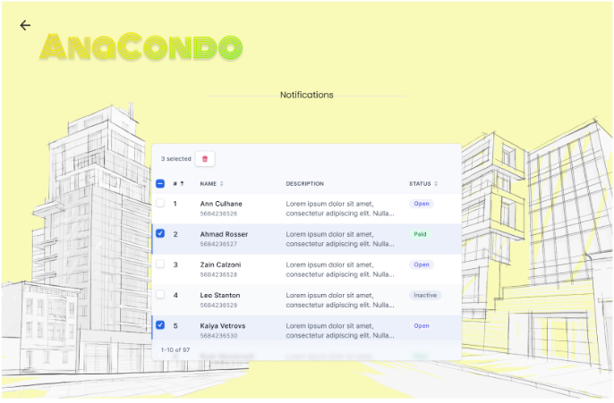

Employee User Page Employee Notifications Page

Steps:

1. The Employee user selects “Notifications”
2. The Employee user changes the status of their requests
3. The user removes the completed requests

**[US-0422 && US-0425]**: [Generate Annual Finance Report && Calculate Operation Costs]

As a condo management administrator, I want to generate an annual report of all condo fees collected in a given year through interacting with a digital element on the financial page, so that I may pay the necessary cost for the upkeep of shared areas, services and management.

As a condo management company user,

I want to be able to view my condo building’s operational budget and cost,

So that I can enter the cost for each operation (condo fees) and display them to unit owners.

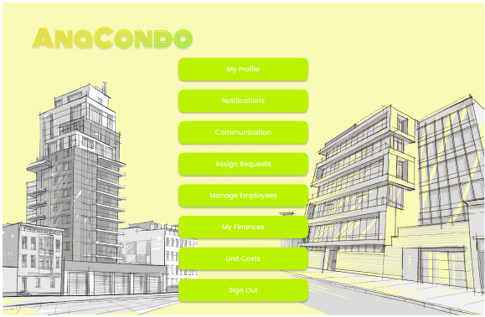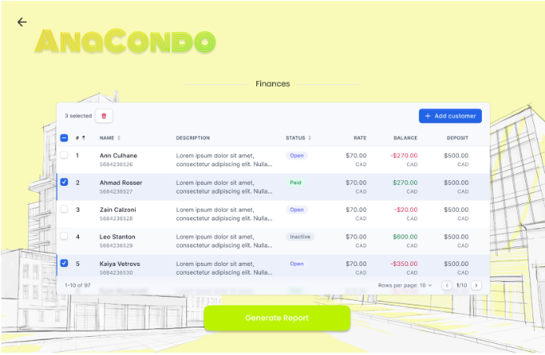

Condo Management Administrator Page Finances Page

Steps:

1. The Condo Management Administrator user selects “My Finances”
2. The Condo Management Administrator user enters the cost for each operations
3. The Condo Management Administrator user selects “Generate Report” which creates a report with all operations displayed on the Finances page

**[US-0423]**: [Setting Condo Unit Costs]

As a condo management administrator, I want to enter the cost of a condominium unit being sold per square foot. Furthermore, I want to enter an added fee per parking spot requested in the purchase of a unit, so that I may place the unit on the market, determine property insurance or factor into the mortgage.

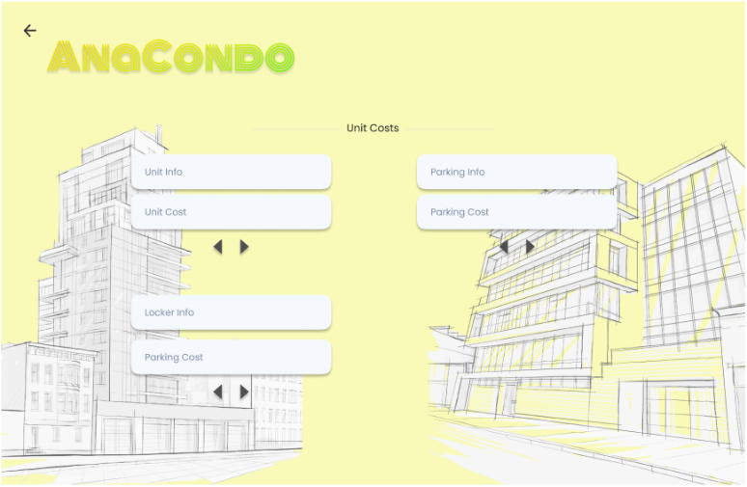

Condo Management Administrator User Page Unit Costs Page

Steps:

1. The Condo Management Administrator user selects “Unit Costs”
2. The Condo Management Administrator enters fees for specifics utilities of the condo

**[US-0424]**: [Calculate Condo Fees]

As a resident, I want the condo fee of each of my units to be calculated and presented in a figure on my properties dashboard, so that I may observe my housing costs and property transactions.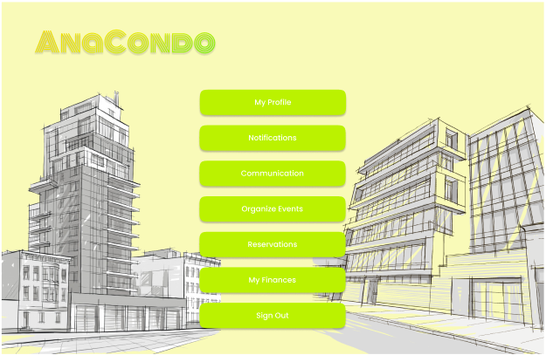

Resident User Page Property List Page

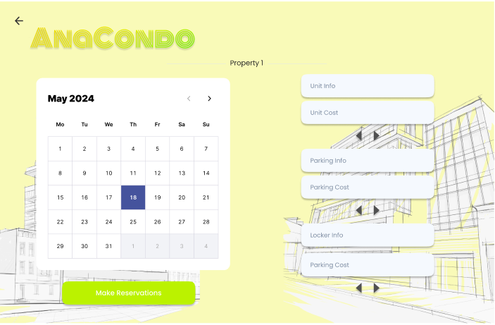

Property Page

Steps:

1. The Resident user selects “Reservations”
2. The Resident user selects the property they wish to view information for
3. The Resident user views the fees of the different units they reserved